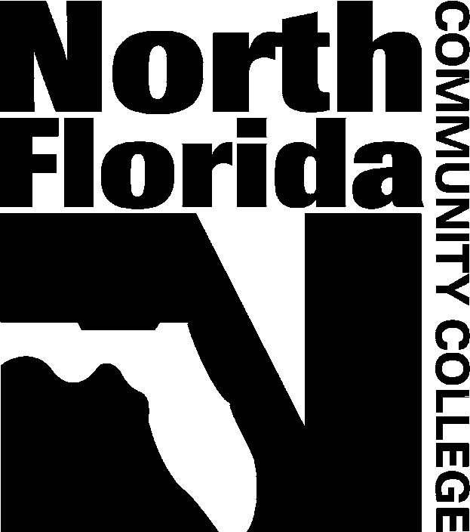
North Florida Community College is an equal opportunity/equal access institution
325 NW Turner Davis Drive
Madison, Florida 32340
Telephone: 850-973-9469
FAX: 850-973-1697
www.nfcc.edu
Enrollment Services

ABSENCE NOTICE

Date: ______/______/______ Term: □ Fall _____ □ Spring _____ □ Summer _____

Student:__________________________________________________________________
First Name Initial Last Name

Student I.D. # G ___________________________

You have missed __________________ from __ __ __ __ __ __ __ __ __ __ __ __ __
C R N Prefix Course Number

Instructor Signature:_________________________________________________________________

Telephone:______________________ E-Mail: ___________________________________

Please check one of the following:

__ You are close to exceeding the allowable absences.
Please contact your instructor.

__ You have exceeded the allowable absences and have been withdrawn by your instructor. A grade of “W” will be issued.

Last date of attendance/electronic contact: ______/______/______

A W may not be assigned after the last published date to withdraw. The student is responsible for officially withdrawing by the last published date to receive a W.

- International students - contact Mrs. Diane Bethea upon receipt of this notice.
- VA students – contact Mrs. Diane Bethea upon receipt of this notice.
- Students on financial aid or receiving a scholarship must meet both the course completion percentage requirement and the cumulative grade point average requirement. Contact the Financial Aid Office for more information.

Registrar Office-White Financial Aid-Yellow Student-Pink

Revised: 1-26-2010

